**Manuals for ‘Manage Photo’**

**Brief of the ‘Manage photo gallery’ –** This is the page where we manage photo.

**1. How to manage photo-.**

Steps:

1. Login to the site and go to ‘Media Room’ tab and click on ‘Manage Photos’.
2. On ‘Manage Photos’ page the listing of photo and ‘Add photo’ button and album name dropdown will display.
3. On this page we can edit and delete the existing records.
4. Click on ‘Add Photo’ button for add new photo.
5. The added new photo will display with on home page photo gallery section.

1.

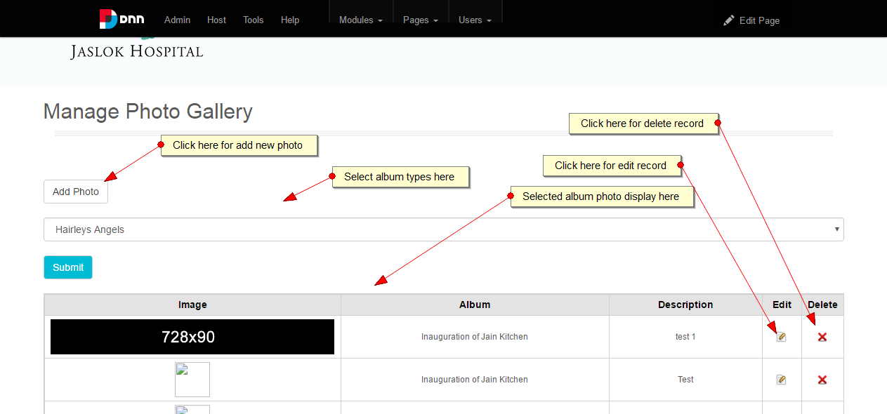

2.

